Text Area: | 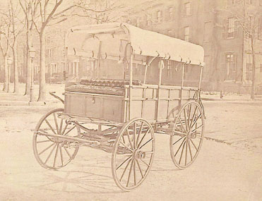  Civil War Ambulance – Side View  Text Area:

