Text Area: | 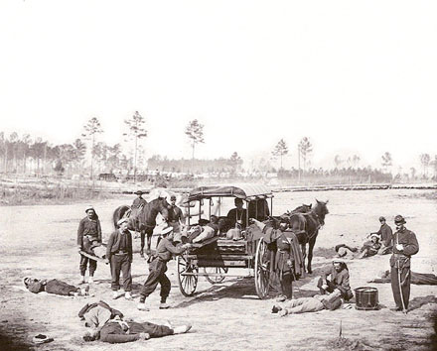  Ambulance Support Troops in Training  Text Area:

