Text Area: | 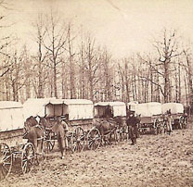  Civil War Ambulance Train

