Text Area: | 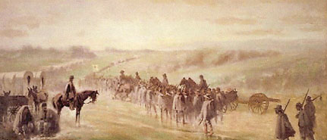  Union Pursuing the Rebels after Gettysburg  Text Area:

