Text Area: | 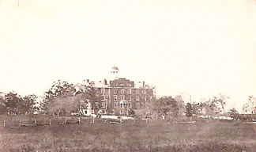  Gettysburg Theological Seminary  A temporary Hospital after 1863 Battle  Text Area:

