Text Area: | 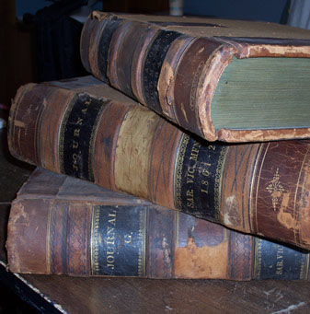  Saratoga Manufacturing Ledgers  Text Area:

