Text Area: | 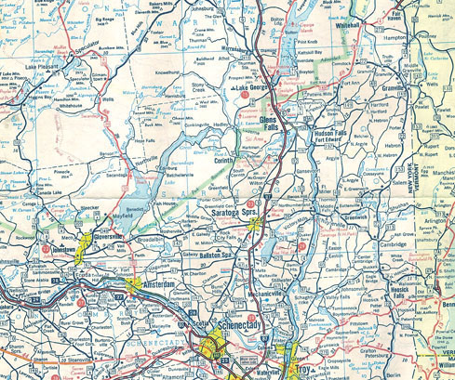  Saratoga County, New York Region  Modern Map  Text Area:

