Text Area: | 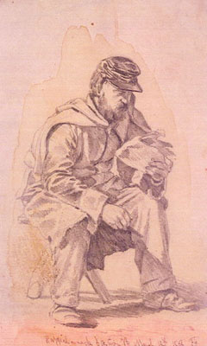  Soldier Reading Letter from Home

