Text Area: | 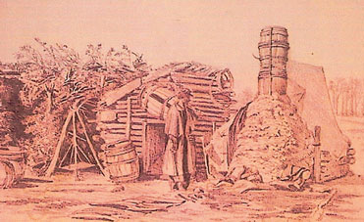  Military Quarters  Tent with Wood Frame and Chimney  Text Area:

