Text Area: | 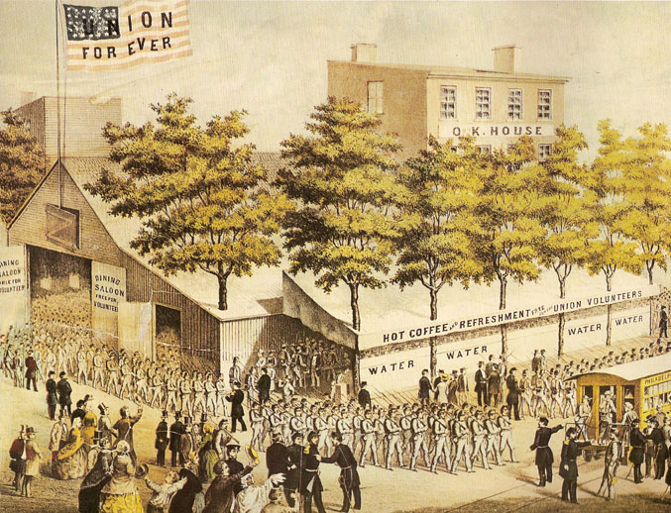  Union Recruits Leave  For Training Camp  Text Area:

